Sahana DAY 4 -ASSIGNMENT

-- 1. List all customers and the products they ordered with the order date. (Inner join)

-- Tables used: customers, orders, order_details, products

-- Output should have below columns:

-- companyname AS customer,

-- orderid,

-- productname,

-- quantity,

-- orderdate

SELECT * FROM CUSTOMERS

SELECT * FROM ORDERS

SELECT * FROM ORDER_DETAILS

SELECT * FROM PRODUCTS

-------Query to get common columns from multiple tables--------------

SELECT column_name

FROM INFORMATION_SCHEMA.COLUMNS

WHERE table_name IN ( 'products','order_details')

GROUP BY column_name

HAVING COUNT(DISTINCT table_name) > 1;

select c.company_name as customer,o.order_id,p.product_name,od.quantity,o.order_date from customers c

inner join orders o on

o.customer_id = c.customer_id

inner join order_details od on

o.order_id = od.order_id

inner join products p on

p.product_id = od.product_id

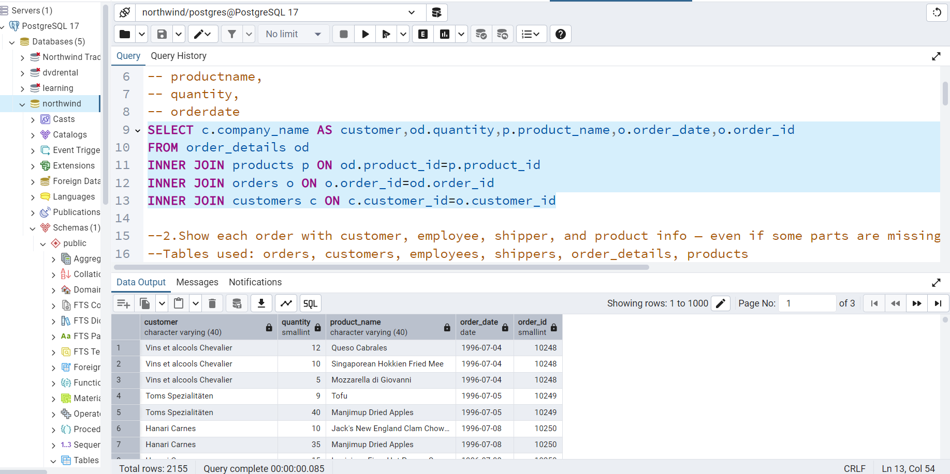

-- 2. Show each order with customer, employee, shipper, and product info — even if some parts are missing. (Left Join)

-- Tables used: orders, customers, employees, shippers, order_details, products

select * from orders

select * from customers

select * from employees

select * from shippers

select * from order_details

-------Query to get common columns from multiple tables--------------

SELECT column_name

FROM INFORMATION_SCHEMA.COLUMNS

WHERE table_name IN ( 'order_details','products')

GROUP BY column_name

HAVING COUNT(DISTINCT table_name) > 1;

SELECT o.order_id,

c.company_name AS customer,

e.first_name || ' ' || e.last_name AS employee,

s.company_name AS shipper,

p.product_name,

od.quantity,

o.order_date from orders o

left join customers c on

o.customer_id = c.customer_id

left join employees e on

e.employee_id = o.employee_id

left join shippers s on

s.shipper_id= o.ship_via

left join order_details od on

od.order_id = o.order_id

left join products p on

p.product_id = od.product_id

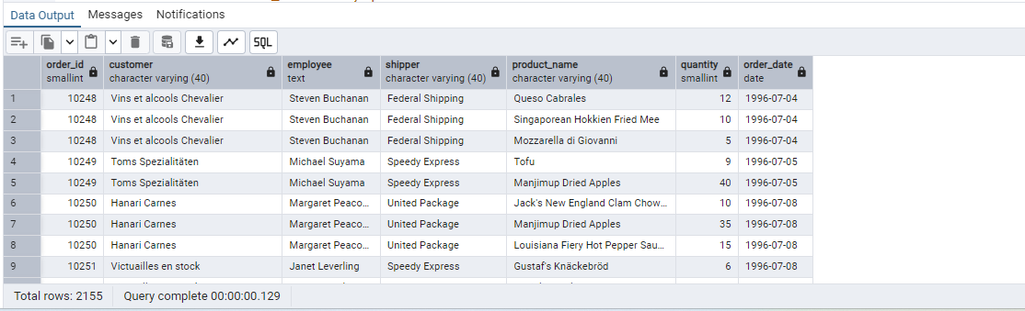

-- 3. Show all order details and products (include all products even if they were never ordered). (Right Join)

-- Tables used: order_details, products

-- Output should have below columns:

-- orderid,

-- productid,

-- quantity,

-- productname

select order_id,p.product_id,quantity,product_name from order_details od

right join products p on

p.product_id = od.product_id

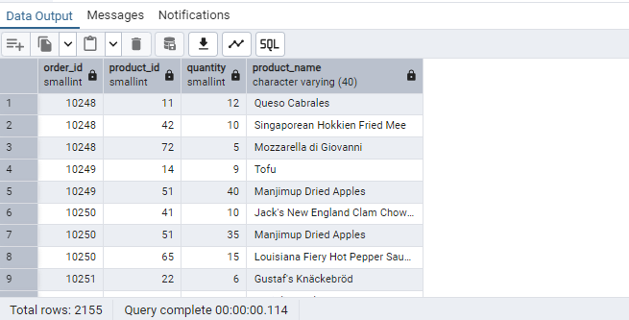

-- 4. List all product categories and their products — including categories that have no products, and products that are not assigned to any category.(Outer Join)

-- Tables used: categories, products

select * from categories

select * from products

select p.category_id,category_name, product_id,product_name from products p

full outer join categories c on

p.category_id = c.category_id

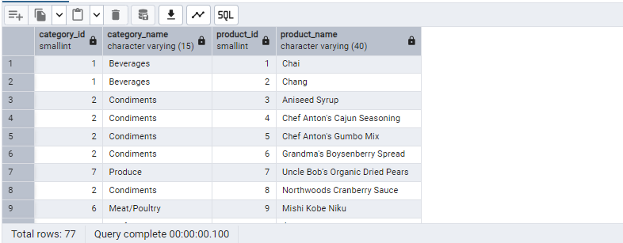

-- 5. Show all possible product and category combinations (Cross join).

------ cross join-----

-- It multiplies the rows of the first table with the rows of the second table.

-- It does not require any condition (like ON or USING).

-------Query to get common columns from multiple tables--------------

SELECT column_name

FROM INFORMATION_SCHEMA.COLUMNS

WHERE table_name IN ( 'categories','products')

GROUP BY column_name

HAVING COUNT(DISTINCT table_name) > 1;

select * from categories

select * from products p

cross join categories ca

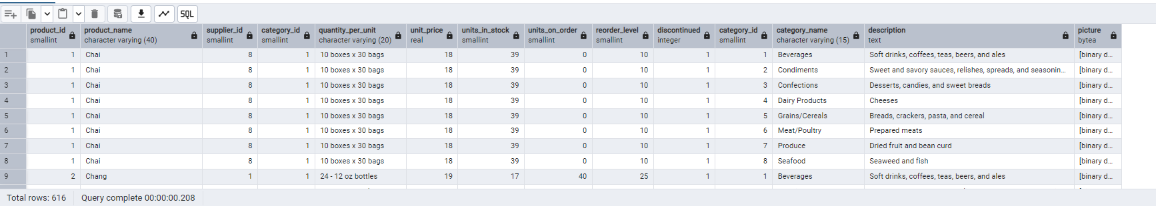

-- 6. Show all employees and their manager(Self join(left join))

select * from employees

SELECT

e.employee_id AS employee_id,

e.first_name || ' ' || e.last_name AS employeename,

m.employee_id AS manager_id,

e.first_name || ' ' || e.last_name AS managername

FROM employees e

LEFT JOIN employees m ON

e.reports_to = m.employee_id

ORDER BY

e.employee_id;

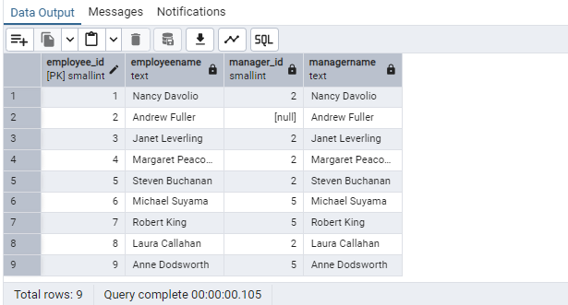

-- 7. List all customers who have not selected a shipping method.

-- Tables used: customers, orders

-- (Left Join, WHERE o.shipvia IS NULL)

select * from customers

select * from orders

select c.customer_id from customers c

left join orders o on

c.customer_id = o.customer_id

where ship_via is null

